RailAdventure puts dual-mode locomotive into service

With a Siemens Vectron Dual Mode, RailAdventure gains new opportunities for combined operation on electrified and non-electrified lines.

Munich, March 2026 – RailAdventure, Europe’s specialist for exceptional rail transports, is expanding its fleet with a powerful dual-mode locomotive of the Siemens Vectron Dual Mode type. Following the contract signing in March, the special locomotive is expected to enter service in the fourth quarter of 2026.

“For RailAdventure, the Vectron Dual Mode is above all an investment in productivity and flexibility,” emphasizes RailAdventure Managing Director Harald Klein. “With the Vectron Dual Mode, we can guarantee faster turnarounds and support our customers even more efficiently. Overall, the locomotive is an excellent fit for the services we provide for our customers.”

Siemens Mobility first presented the Vectron Dual Mode at InnoTrans 2018. As the term “Dual Mode” suggests, the locomotive can be operated either electrically or in diesel mode: fully electric operation on electrified sections saves fuel, reduces emissions, and lowers maintenance costs. On sections without overhead lines, it can then switch to diesel operation.

In Germany, for example, the level of electrification is increasing, but currently stands at only just over 60 percent. With the Vectron Dual Mode, such gaps can be covered without complex locomotive changes – a solution that is both economical and sustainable.

“The Vectron Dual Mode is ideally suited to RailAdventure’s operational business because it offers sufficient traction power for our transfer operations and can switch freely between electric and diesel traction,” adds RailAdventure Managing Director Jörg Schurig. “From a strategic perspective, this means fewer locomotive changes, more flexible dispatching, lower costs, and a better environmental footprint. In addition, we can use the new locomotive for further test runs and thus help to steadily expand its area of use in Europe.”

The dual-mode locomotive is currently approved by the European Union Agency for Railways for operation in Germany, Austria, and cross-border traffic between the two countries. Further countries are expected to follow. In the specific case of the model ordered by RailAdventure, approvals for Slovakia and the Czech Republic are also planned.

The dual-mode variant is based on the proven Vectron platform. It has a track gauge of 1,435 millimetres and weighs around 90 tonnes. The locomotive is designed for the 15 kV AC power system and equipped with the ETCS train protection system. With traction power at the wheel of up to 2,000 kW in diesel mode and 2,400 kW in overhead line operation, its top speed is 160 km/h. A 2,600-litre tank is installed for the 2,400 kW diesel engine. The locomotives are manufactured at Siemens Mobility’s plant in Munich-Allach.

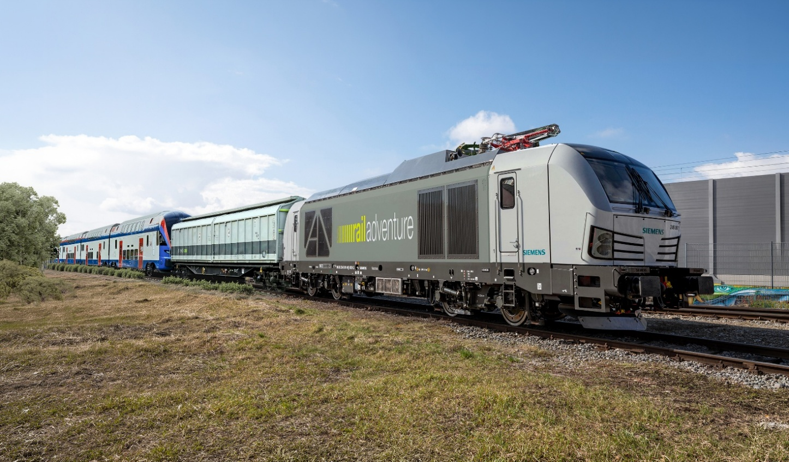
(Photo credit: Siemens Mobility GmbH)
Image (PI_Railadventure_Vectron_Dual_Mode.jpg)

With the Siemens Vectron Dual Mode dual-mode locomotive, RailAdventure increases both productivity and flexibility.

About RailAdventure
As a neutral service provider, RailAdventure specializes in the high-quality execution of test runs and transfer operations for the rail industry. For this purpose, the company maintains specially developed assets: RailAdventure owns locomotives, coupling adapter and brake wagons, as well as its in-house developed and patented Loco Buggy transport system for moving vehicles with different track gauges. Its permanent staff, most of whom are multilingual, include specially trained locomotive drivers, technicians, and test managers. RailAdventure GmbH is a member of the German Railway Industry Association (VDB). In addition to its headquarters in Pullach near Munich and its Zughotel facility in Braunschweig, including its own underfloor wheel lathe, the company also has subsidiaries in France, Great Britain, and the Netherlands.

Further information is available at www.railadventure.de.

